John Michael Go
Career Entry Level Java Programming
Date: Jan. 17, 2013

DAY 5

Program Name: DateTime3

Objective: Third Date and Time example

Algorithm:

- Program outputs third date and time format.

Flowchart:

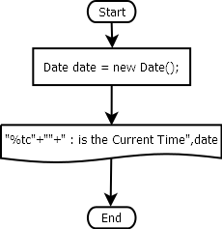
Pseudocode:

/* Program Name: DateTime3
Created By: John Michael Go
Creation Date: Jan. 17, 2013 Day 5
Note: Third Date and Time example
*/

import java.util.*;

public class DateTime3{

public static void main(String[]args){

Date date = new Date();

System.out.printf("%tc"+""+" : is the Current Time",date);

System.out.println("");

}

}

Screenshot:
